Multi Threading

Multithreading is a process to execute multiple threads at the same time without dependency of other thread called multithreading.

Main method

In thread task execute one time

Task 1

Deposit

Withdraw

Check balance

Task 1

Task 1

What is Thread in java?

A thread is a lightweight sub-process, the smallest unit of processing. It is a separate path of execution.

Threads are independent. If there occurs exception in one thread, it doesn't affect other threads. It uses a shared memory area.

Multi Threading way to create

1. By extending Thread class
2. By implementing Runnable

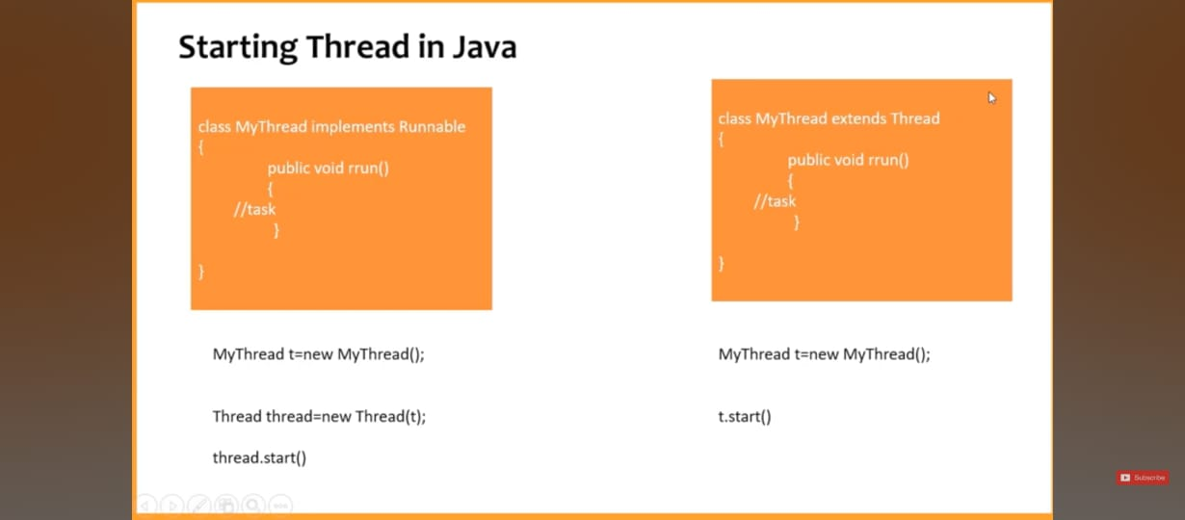

If we implements Runnable

Runnable does not have start method, runnable have only run() method

So we need create object of thread.

Because thread have start method.

if we we runnable then we can extend class

it don’t have multiple inheritance problem

If we use extend thread then we can not extend onthor class

It have multiple inheritance problem